Yinghui Qiang (19692)

MATH201 Calculus I

PLO Signature Assignment

Dr. Alex Young

August 14, 2023

Table of Contents

1. **INSTRUCTION TO Newton’s MATHOD -----------------------------------------------1**

definition of newton’s mathod

how to apply newton’s mathod

1. **problem and solution ------------------------------------------------------------------ 2**

Question 𝑒x =4 – 𝑥2

Solution

Explanation analysis process

TREND LINE

Prediction Based on Trend Data

ERROR

1. **The threat ISSUES ------------------------------------------------------------------------- 4**

PROS AND CONS

limitation of newton’s method

evidence

1. **influence of context and assumption ------------------------------------- 5**

Influence

assumption

1. **manager’s position ----------------------------------------------------------------------- 6**

1. **conclusion -------------------------------------------------------------------------------------6**

a effective way but has its limitations

1. **Reference lists ------------------------------------------------------------------------- 7**

**Newton’s Method in Solving the Problems**

1. **Introduction to Newton’s Method**

**Newton’s Method**was developed in the 17th century by Joseph Raphson and Isaac Newton. Newton’s Method is to look for a way to get close to the honest answers and use the derivative to find out what the function is doing to track the changes.

**Newton’s Method**, the Newton-Raphson Method, is essential in approximating numerical solutions to solve equations without formulas. This Method creates high accuracy, such as finding the roots, x-intercept, or zeros. For example, there are no formulas for these equations to find f(x)=0

X+ $e^{4x}$ = 8

Tan(x)+ Cos(x) = 3.5

F(x) = x6+8x4+5x2-18

**Newton’s Method,** for a single-variable function *f* (x), need to find out *f′* and *x*0, and the root of f*(x)*.

If x1=x0 - , then (x1, 0) is the tangent line of x0, *f* (x0).

Repeat the process, xn+1=xn - until the approximant value is reach. In each step the accuracy of the number will doubles.�1=�0−�(�0)�′(�0)

**Using Newton’s Method to identify the problems:**

1. Root finding
2. Differentiable functions
3. Local solutions

## **Apply Newton’s Method**

To apply Newton’s Method, choose the initial independent variable value of x0, then use the tangent line to determine a different x-intercept, and repeat the process until getting close to the result of y=0 when x=r.

Table 1.

Note: Herman, Edwin. (n.d.). *Newton’s Method*. Libretexts Mathematics.https://math.libretexts.org/Bookshelves/Calculus/Map%3A_Calculus__Early_Transcendentals_(Stewart)/04%3A_Applications_of_Differentiation/4.08%3A_Newton's_Method

Assume the initial x value is x0, we need to find out the if f (x0) =0. If f (x0) ≠0, then apply x1, and repeat the same process until f (xi) really close to 0.

1. **Problems and Solutions**

Question: Approximate the negative root of the equation 𝑒x =4 – 𝑥2, correct to six decimal places. And verify your answer by the plot in Excel.

ANS: The negative root of the equation of 𝑒x =4 – 𝑥2 is when x $≈$-1.964636, f(x) = 0.0000015, which f(x)is really close to 0.

Step 1: By observation of graph of

F(x)= 𝑥2 + 𝑒x – 4.

Step 2. Plot in the data, look for f(x)=0

𝑒x - 4 + 𝑥2 =0 or 𝑥2 + 𝑒x - 4 =0

F(x) = 𝑥2 + 𝑒x - 4 =0

when x closes to -1.965 and x close to 1.058, f(x) is close to 0. The negative root of x is

close to -1.965. Choose the data with six.

decimal places to plot in Excel.

1. Plot the data with six decimal places close to -1.965 in Excel.

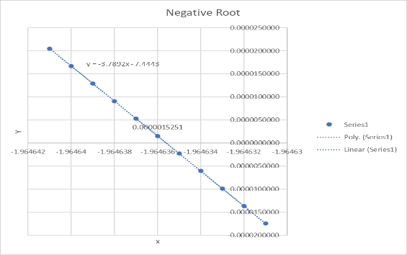

Since the selected data is small, the graph shows a linear function, with a negative slope. When x increases, y decreases.

1. Plot the data with six decimal places close to 1.058 in Excel.

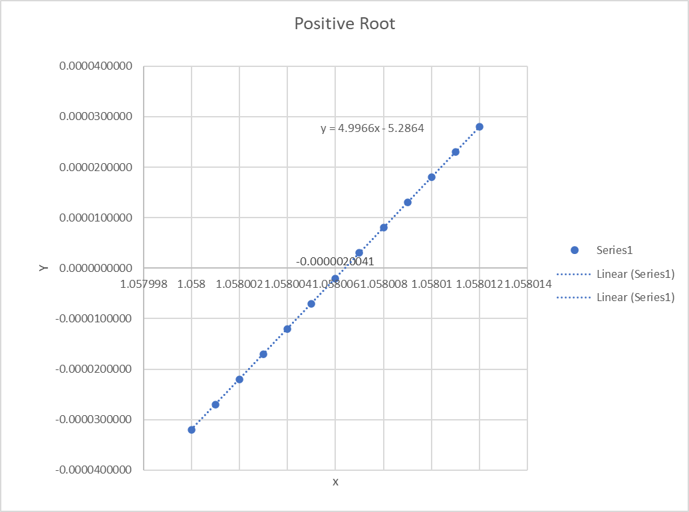

Since the selected data is small, the graph shows a linear function, with a negative slope. When x increases, y decreases.

Step 3. To prove the negative root of equation, test different x value to get f(x) close to 0.



**Trendline**

Data shows that Negative root equation is.

y = -3.7892x - 7.4443,

Positive root equation is y= 4.9966x-5.2864

When adding negative and positive root together, equation became y = 1.4433x2 + 1.3085x - 3

**Prediction based on Trend Data**

The trend data shown in graph is a parabola that has no endpoints. The line extends infinitely upward on both left and right side. It indicates x has 2 roots, a positive root, and a negative root. The trend line contains absolute minimum value when x is equal to 0, then y= -3. There is no maximum value since y is toward infinity above the x exile. When x (ꝏ, 0), y decreases, when x (0, ∞), y increases.

**Errors**

After plotting selected x value ( -2, 1.1), polynomial trendline is away from the original graph, and the equation is different. The absolute minimum value shifted left and down from (0, -3) to the point of (-3.5, -0.5).

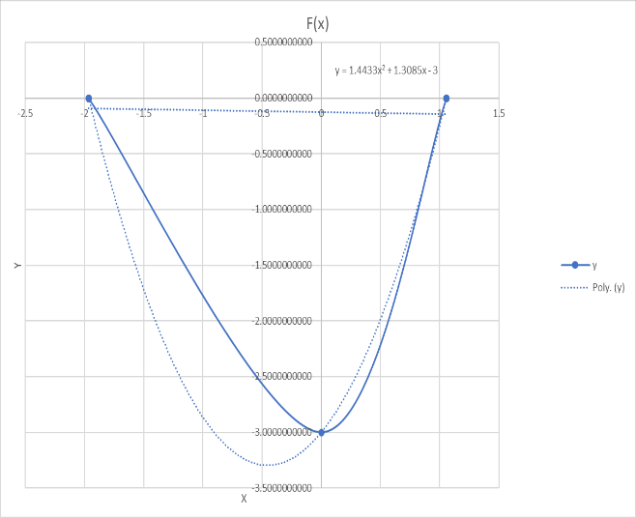

**Explanation analysis process**

**Step 1.** Choose the initial value.

F’(x) **=** (𝑥2+𝑒x-4)’=0

**F’(x) =**2x+e×1-0=0

**F’(x)** = 2x = -e then x=

Let x0 = = -1.359141

F(-1.359141) = 𝑥2 + 𝑒x - 4 =

( -1.359141)2+e (-1.359141)-4 = -1.968796

Since f(x) is not equal to 0, -1.369141 is not the negative root of this function.

**Step 2.** Test the x value until f(x) equal to 0 or really close to 0.

**Select x0=**-1.359141 as the initial value,

**Select** x1= -1.4 as the second value, input to the function,

F(-1.4) = 𝑥2 + 𝑒x - 4 = (-1.4)2+e(-1.4)-4

= -1.856060

Verify with F(x1)-f(x0) = f’(x0)(x1-x0)

F(x1)= (-1.359141)×[-1.4- (-1.359141)]+

[( -1.359141)2+e (-1.359141)-4]

=-1.840322

Therefore when x1= -1.4, f(x1)≠0

x1 is notthe root.

Repeat the process until f(x) =0 or close to 0.

**Step 3**. Apply f’(x) function to prove that f(xi)=0.

F(x2)-f(x1) = f’(x1)(x2-x1)

F(x2)= f’(x1)(x2-x1)+ f(x1)=0

1. **The Thread Issue**

**Newton’s Method Pros & Cons**

**Newton’s Method is a good tool for solving problems but has limitations and disadvantages.**

**Advantages include efficiency, ease of application, and fitness. It forms quadratic convergence that accuracy doubles with each iteration. The root is when the f(x) is equal to 0. Easy to find the local convergence.**

**Disadvantages include a slow and challenging way to find the initial. It requires many steps to get the result, and an incredible amount of data to verify the result. Applying the for (x) function increases the complexity. It is hard to compute in the multiple variable values and can contain discontinuous functions. High dimensional problems cause high levels of derivatives that lead to time and cost consumption.**

**Limitation**

1. Fail to converge when the initial value is not close enough to the actual root.
2. If the equation has multiple roots, it may not converge to a solution.
3. The initial value determines the success rates of this method.
4. The derivative requirement in the calculation.
5. Hard to apply if the function has high dimensions and many parameters.
6. If multiple roots are close to each other, the result can be wrong.
7. Diverge issue.
8. High cost.

**Alternative Method**

**Gradient descent** can replace **Newton’s method** when the function has a high dimension with significant parameters. But this method also has its limitations, which require the function to be continuous and differentiable.

In a different situation where the function has many linear and nonlinear functions, **Iterative Solvers** are much more effective than **Newton’s method**.

**Evidence**

Example 1. F(x)= 39x2-2x -6. If the initial guess is not close enough to the true root, such as x0=25, the iteration cannot converge.

Example 2. F(x) = x5+ 2x3+39x2-2x -6 has 5 roots, cannot converge to all 5 roots.

Example 3. F(x)=|x|+1. Since F’(x) is not defined, converge fail.

Example 4. F(x) = $\sqrt{\left|x\right|}$ +5. If his function is discontinued, it will affect the result.

1. **influence of context and assumption**

**Influence**

**Newton’s Method is a numerical method widely used in scientific fields such as physics, machine learning, biology, chemistry, engineering, economics, and financing. It is an effective tool for scientific study in modeling and equation solving.**

**It is not the best method to use in machine learning because of its limitation and inaccuracy of the outcome.**

**Assumption**

**Newton’s method takes assumption of f(x) is differential at the root when x=r, and f’(x) exits. The function is continuous and has derivatives. It appears as a straight line when use very small data that close to each.**

1. **Manager’s Position**

Managers apply Newton’s method in making decisions, problem-solving, and future predictions. It is an excellent tool for managers to use in communication. Managers can use this method in financial analysis, quality control, cost reduction, and risk management.

Managers with limited knowledge and resources in numerical methods might need help applying and understanding. Manager mainly focuses on time management, resource allocation, and performance evaluation. Failure to achieve the objective can cause company loss. Therefore, Newton’s method is not a tool to use every day.

1. **Conclusion**

**Newton’s Method is an effective way to**

in numerical computation of the quantitative analysis of data. It requires an initial guess on the number that is close to f(x) = 0. It uses the tangent line slope to find out the roots of the function. It is easy to understand and implement.

However, it can be time-consuming, and there are better methods for solving specific problems because of its limitations and failure to reach a result. This method is more suitable for studying chemistry, economics, biology, engineering, and physics. Its accuracy suppresses its compilation; Newton’s Method is a powerful tool for real-world problem-solving.

**References**

Herman,Edwin. (n.d.). *Newton’s Method*. Libretexts Mathematics. https://math.libretexts.org/Bookshelves/Calculus/Map%3A_Calculus__Early_Transcendentals_(Stewart)/04%3A_Applications_of_Differentiation/4.08%3A_Newton's_Method

.

Gershon, Ariel, Yung, Edwin, & Khin, Jimin.(n.d.) *Newton Raphson Method*. Brilliant. <https://brilliant.org/wiki/newton-raphson-method/>

Calc Workshop. (February 22, 2021). *Newton’s Method. How to step by step examples!* Calc

Workshop. https://calcworkshop.com/derivatives/newtons-method/

Meza, Juan. (March 15,2010). Newton’ Method.